**In the name of Allah, the Most Gracious and The Merciful**



**Project Title: DNS Lookup**

**Computer Networks Lab (CSC-203L)**

**Group # 01**

|  |  |
| --- | --- |
| 2023-CS-455 | Eman Fatima |
| 2023-CS-466 | Muhammad Mudasser |
| 2023-CS-467 | Ghulam Zikriya |
| 2023-CS-473 | Jazib Farid |
| 2023-CS-486 | Hammad Ehsan |

Submitted To**: Sir Syed Muhammad Mehdi**

**Semester: Fall 2024**

**B.Sc. Computer Science**

**Introduction**

DNS (Domain Name System) lookup is the process of translating a domain name (like www.example.com) into its corresponding IP address (like 192.168.1.1) so that computers can communicate over the internet. This translation is necessary because while humans find it easier to remember domain names, computers rely on IP addresses to identify and connect to servers.

**Working:-**

* A Client sends a query to DNS Server.
* DNS Server then sends it to the DNS Resolver.
* And then Resolver map the query of client with corresponding ip address and returns to the DNS Server and server then return the response to client!

**Project Working Flow**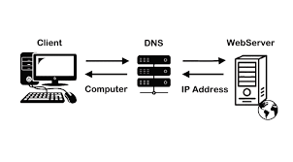

**DNSRESOLVER**

**DNS**

**CLIENT**

**System Architecture**

**Components:**

1. **Server**:
   * The DNS server processes queries from clients and returns the appropriate DNS records.
   * It stores a database of DNS records for the domain names it manages.
2. **Clients**:
   * The clients send DNS queries to the server for specific records (e.g., MX, A, CNAME, PTR).
   * Each client can query a different record or request all records.

**Network Setup:**

* **Server**: Listens on a fixed IP and port (e.g., 192.168.1.1:53).
* **Clients**: Connect to the server over a TCP or UDP socket.

**Scenario 1**

To check the client and DNS server pc is connected to each other we must ping both pcs .So that we get to know that they are in the same LAN. And they can be communicate to each other so that the DNS lookup can be performed.

**OUTPUT**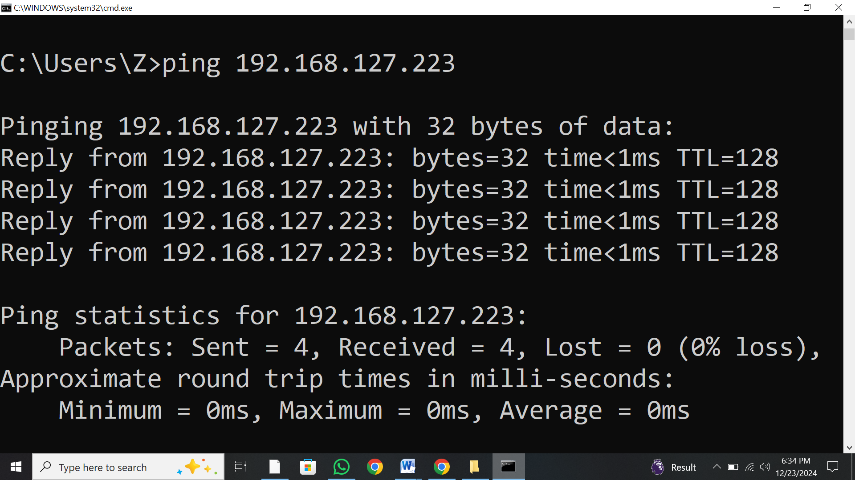

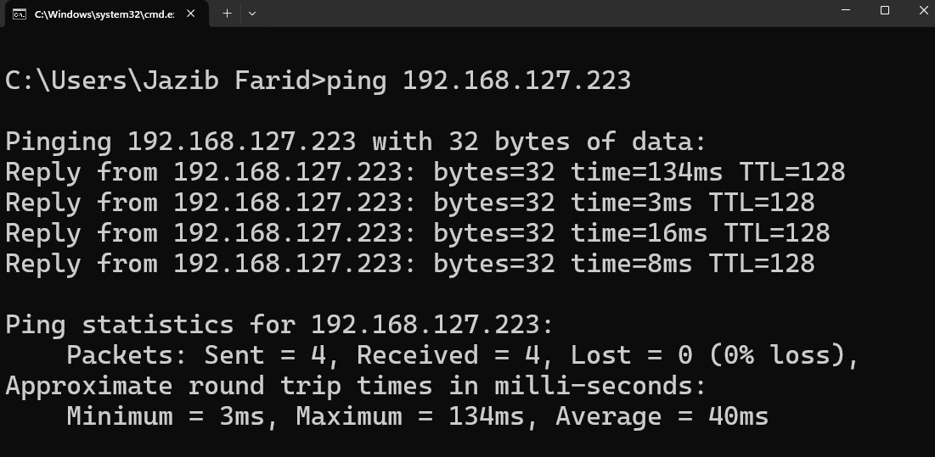

**Scenario 2**

We make the interface of client server and some tools like:-

* Text box to enter the domain name or ip to request to the server.
* Combo box for options like A, MX, CNAME and PTR.
* Button for entering the commands.
* Listbox to show the list of results.
* Labels for the textbox, listbox, combo box and for the button.

**OUTPUT**

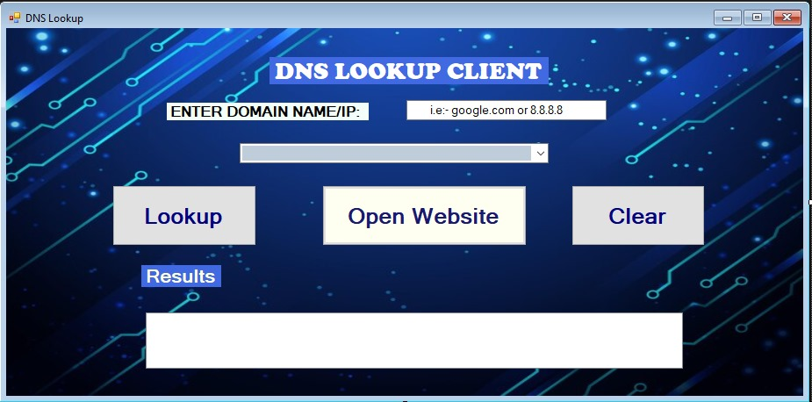

**Scenario 3**

**For option A:-**  
Now when the client requests to the dns server the domain nametill now the button of open website will not open because the dns server does not return the ip address when the dns server should return the ip address for that particular domain name button will be automatically enabled because we embedded http server in the dns server.

**For option MX:-**For mail exchange option it will return the mail exchange for that particular domain name   
For ip address it will not return the mail exchange because it is only applicable for domain names.  
**For option PTR:-**For pointer to reverse option server should return the domain name when the client enter the ip address website will be loaded for both processes (i.e, for ip address, for domain name ).  
  
**OUTPUT**

**For option A:-**

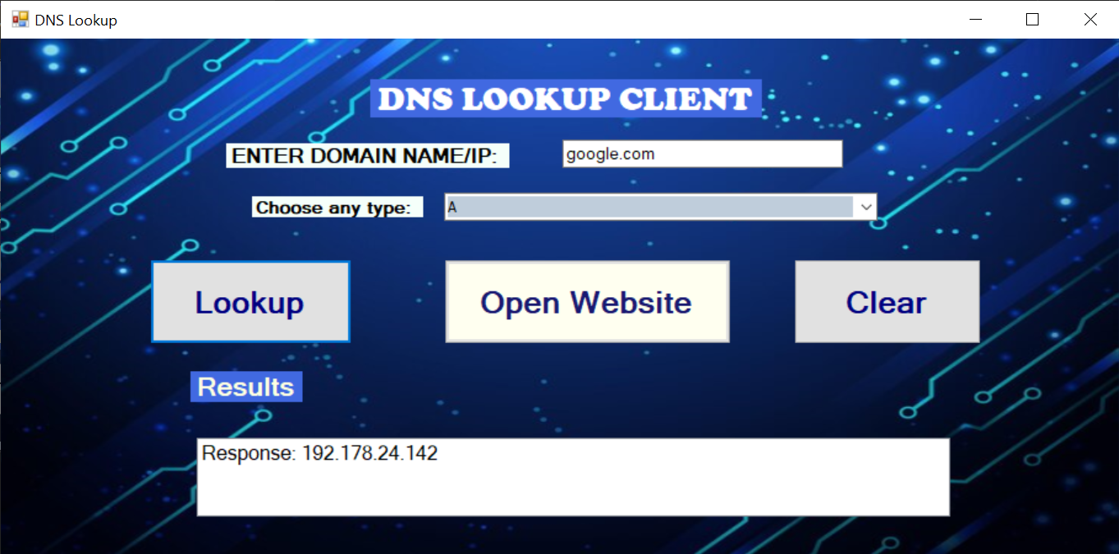

**For option MX: For option PTR:**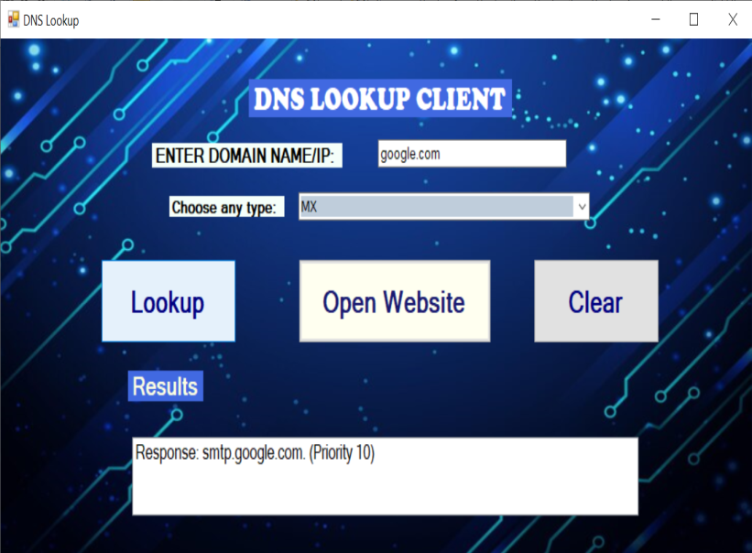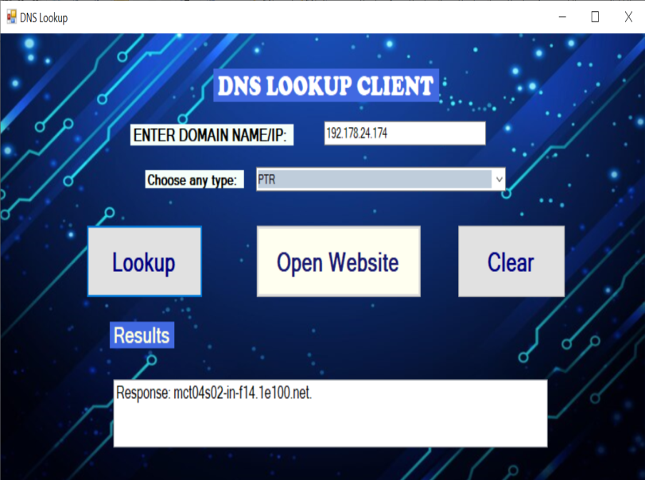

For all options website google is open because the A, MX, and PTR belongs to the google.

**Reply from DNS Server:-**

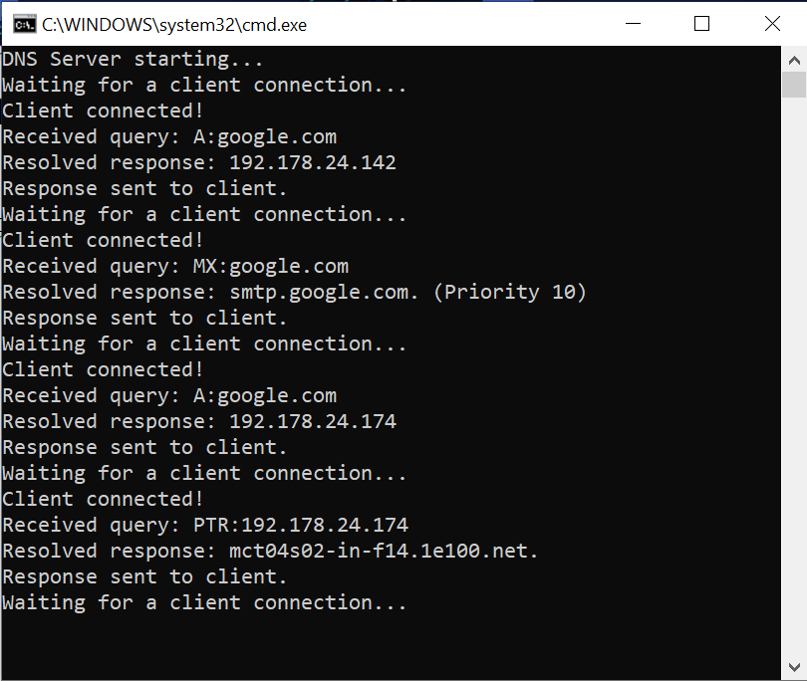

**Conclusion:**

This project demonstrates the implementation of a basic DNS query system with a centralized server and multiple clients. It provides a practical understanding of DNS mechanisms, including record management, query resolution, and client-server communication